3.1 System Use Case of Login Page
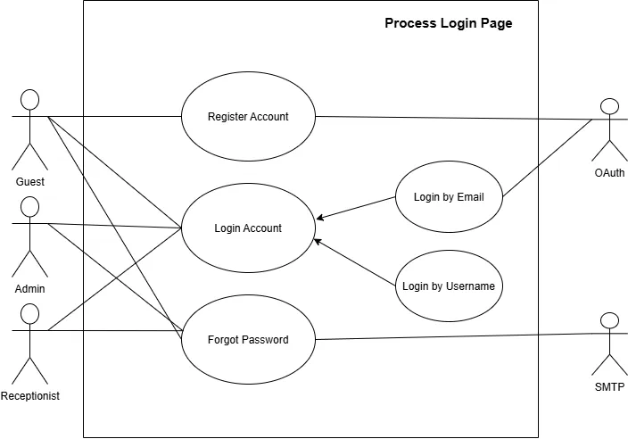
Figure 3.1 System Use Case of Login Page
Written Use Case:
Use Case Name: Register Account
Purpose: Allows the guest to create an account in the system by continuing with their Google account and setting a username and password.
Actors: Guest, OAuth
Input Parameters:
- Google Account (chosen through OAuth)
- Consent to Personal Data Processing
- Username
- Password
- Confirm Password
Output Parameters:
- Created Guest Account
- Confirmation Message
- Error Message
Pre-Condition:
- The guest does not have an account yet.
- The guest is not signed in.
- The guest has a Google account.
- Sign in with Google (OAuth) is set up in the system.
Post-Condition:
- A new guest account is saved with the guest’s Google name and verified email, the chosen username, and the password.
- The guest can now log in by email or username.
Successful Scenario:
- The guest opens the Login page (Sign In or Join) and selects Continue with Google.
- The guest signs in to Google and chooses the Google account to use.
- Google shows the information that the hotel site will receive (name, profile picture, and email address), and the guest selects Continue.
- The system verifies the Google account with OAuth and checks that the Google email is not yet registered.
- The system displays the “Before we create your guest account” page, which explains the personal data that will be used, why consent is asked, the stay and account rules, and the guest’s rights.
- The guest reads the summary, ticks the consent checkbox, and selects Agree and continue.
- The system displays the Create your password page, with the Google email shown as fixed and a suggested username.
- The guest changes the username if needed, enters a password, confirms the password, and selects Save password.
- The system validates the username and password, and checks that the username is not yet used.
- The system saves the new guest account, with the password stored in encrypted form.
- The system displays a confirmation message.
Exception Scenario:
- If the guest cancels at the Google sign-in, the Google permission screen, or the consent page:
○ The system does not create an account.
- If the Google account cannot be verified:
○ The system displays an error message and allows the guest to try again.
- If the Google email is already registered:
○ The system does not create a second account and asks the guest to log in instead.
- If the guest does not tick the consent checkbox:
○ The system does not allow the guest to continue until consent is given.
- If the username is already used or invalid:
○ The system asks the guest to choose a different username.
- If the password is missing, weak, or the two entries do not match:
○ The system asks the guest to enter a valid password.
Additional Remarks:
- Only guests can register on their own. Admin and Receptionist accounts are created by the admin (see Manage Users).
- Registration is done through a Google account using OAuth. The guest’s name and email come from Google, and the email stays fixed on the account.
- The guest may change the suggested username before saving. After registering, the guest can log in by email or username (see Login by Email and Login by Username).
- The guest’s consent is required before the account is created. The guest may ask the hotel to access or correct their data, or to withdraw consent.
- Passwords are saved in a protected (encrypted) form.
Written Use Case:
Use Case Name: Login Account
Purpose: Allows the guest, admin, or receptionist to sign in and use the features that belong to their role.
Actors: Guest, Admin, Receptionist
Input Parameters:
- Login Credentials (Email or Username, and Password)
Output Parameters:
- Signed-in Session
- Role-based Home Page
- Error Message
Pre-Condition:
- The user has a registered account.
- The account is active.
Post-Condition:
- The user is signed in.
- A session is created for the user.
Successful Scenario:
- The user opens the Login page.
- The user chooses to log in by email or by username (see Login by Email and Login by Username).
- The user enters their credentials and submits.
- The system verifies the credentials.
- The system creates a session for the user.
- The system directs the user to the page that matches their role.
Exception Scenario:
- If the credentials are incorrect:
○ The system displays an error message and allows the user to try again.
- If the account is inactive or disabled:
○ The system does not allow the sign-in and informs the user.
- If the user fails to log in too many times:
○ The system blocks further attempts for a while.
Additional Remarks:
- Login Account is the general use case. Login by Email and Login by Username are the two ways it can be done.
- All three roles use the same Login page. What the user can open depends on their role.
- A user who forgot their password can use Forgot Password.
Written Use Case:
Use Case Name: Login by Email
Purpose: Allows the user to sign in using their registered email address.
Actors: Guest, Admin, Receptionist, OAuth
Input Parameters:
- Email Address
- Password, or OAuth Email Account
Output Parameters:
- Signed-in Session
- Error Message
Pre-Condition:
- The user has an account with a registered email address.
- The account is active.
Post-Condition:
- The user is signed in.
- A session is created for the user.
Successful Scenario:
- The user opens the Login page and selects login by email.
- The user enters their email address and password, or continues with their email account through OAuth.
- The user submits the login.
- The system verifies the email address and password, or the identity confirmed by OAuth.
- The system signs the user in and creates a session.
Exception Scenario:
- If the email address is not registered or the password is wrong:
○ The system displays an error message and allows the user to try again.
- If the OAuth account cannot be verified:
○ The system displays an error message and allows the user to try again.
- If OAuth is not set up:
○ The system hides the OAuth option and only allows email and password login.
Additional Remarks:
- Login by Email is a specific way of doing Login Account.
- The email address entered must match the one saved in the user’s account.
Written Use Case:
Use Case Name: Login by Username
Purpose: Allows the user to sign in using their username.
Actors: Guest, Admin, Receptionist
Input Parameters:
- Username
- Password
Output Parameters:
- Signed-in Session
- Error Message
Pre-Condition:
- The user has an account with a username.
- The account is active.
Post-Condition:
- The user is signed in.
- A session is created for the user.
Successful Scenario:
- The user opens the Login page and selects login by username.
- The user enters their username and password.
- The user submits the login.
- The system verifies the username and password.
- The system signs the user in and creates a session.
Exception Scenario:
- If the username does not exist or the password is wrong:
○ The system displays an error message and allows the user to try again.
- If the account is inactive or disabled:
○ The system does not allow the sign-in and informs the user.
Additional Remarks:
- Login by Username is a specific way of doing Login Account.
- Each username is unique to one account.
Written Use Case:
Use Case Name: Forgot Password
Purpose: Allows the user to reset a forgotten password through a reset link sent to their email.
Actors: Guest, Admin, Receptionist, SMTP
Input Parameters:
- Registered Email Address
- New Password
- Confirm New Password
Output Parameters:
- Password Reset Email
- Password Reset Confirmation
- Error Message
Pre-Condition:
- The user has a registered account.
- The email service (SMTP) is available.
Post-Condition:
- The password is changed.
- The reset link can no longer be used.
Successful Scenario:
- The user selects Forgot Password on the Login page.
- The user enters their registered email address.
- The system checks that the account exists.
- The system sends a password reset link to the user’s email through SMTP.
- The user opens the link from the email.
- The user enters and confirms a new password.
- The system validates and saves the new password.
- The system displays a confirmation message and asks the user to log in.
Exception Scenario:
- If the email address is not registered:
○ The system displays a general message that does not reveal whether the account exists.
- If the email cannot be sent:
○ The system displays an error message and asks the user to try again later.
- If the reset link is expired or already used:
○ The system rejects the link and asks the user to request a new one.
- If the new password is weak or the two entries do not match:
○ The system asks the user to enter a valid password.
Additional Remarks:
- SMTP is the external email service that delivers the reset link.
- The reset link is only valid for a limited time and can only be used once.

3.2 System Use Case of Users
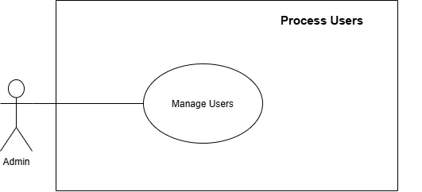
Figure 3.2 System Use Case of Users
Written Use Case:
Use Case Name: Manage Users
Purpose: Allows the admin to add, view, edit, deactivate, and delete user accounts of the system.
Actor: Admin
Input Parameters:
- Search Keyword or Filter
- User Details (Name, Email Address, Username, Role, Status)
- Selected Action (Add, Edit, Deactivate/Reactivate, or Delete)
Output Parameters:
- List of Users
- Saved User Changes
- Confirmation or Error Message
Pre-Condition:
- The admin is signed in.
Post-Condition:
- The changes to the user accounts are saved.
- The action is recorded in the audit logs.
Successful Scenario:
- The admin opens the Users page.
- The system displays the list of users with their roles and statuses.
- The admin searches for a user or chooses an action: add a user, edit a user, deactivate or reactivate a user, or delete a user.
- The admin enters or changes the user details and submits.
- The system validates the details.
- The system saves the changes and updates the list of users.
- The system displays a confirmation message.
Exception Scenario:
- If required details are missing or invalid:
○ The system asks the admin to complete or correct the required information.
- If the email address or username is already used by another user:
○ The system rejects the change and asks the admin to use a different one.
- If the admin tries to deactivate or delete their own account:
○ The system blocks the action.
- If the list of users cannot be loaded:
○ The system displays an appropriate error message.
Additional Remarks:
- Only the admin can manage users.
- A deactivated user cannot log in, but the user’s records are kept.
- The admin cannot see the passwords of users.

3.3 System Use Case of Room Management
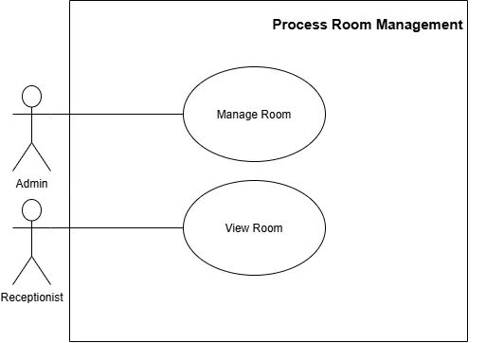
Figure 3.3 System Use Case of Room Management
Written Use Case:
Use Case Name: Manage Room
Purpose: Allows the admin to add, edit, and delete rooms, and to set their details, prices, and status.
Actor: Admin
Input Parameters:
- Room Details (Room Number, Room Type, Description, Photos, Inclusions, Capacity, Price)
- Room Status (Available or Unavailable)
- Selected Action (Add, Edit, Change Status, or Delete)
Output Parameters:
- List of Rooms
- Saved Room Details
- Confirmation or Error Message
Pre-Condition:
- The admin is signed in.
Post-Condition:
- The room changes are saved.
- The updated rooms are shown to the guests and to the receptionist.
- The action is recorded in the audit logs.
Successful Scenario:
- The admin opens the Rooms page.
- The system displays the list of rooms with their details and status.
- The admin chooses to add a room, edit a room, change a room’s status, or delete a room.
- The admin enters or changes the room details and saves.
- The system validates the details.
- The system saves the room and updates the list of rooms.
- The system displays a confirmation message.
Exception Scenario:
- If required details are missing or invalid:
○ The system asks the admin to complete or correct the required information.
- If the room number already exists:
○ The system rejects the room and asks the admin to use a different room number.
- If the admin tries to delete a room that has active or upcoming bookings:
○ The system blocks the deletion and informs the admin.
- If the list of rooms cannot be loaded:
○ The system displays an appropriate error message.
Additional Remarks:
- Only the admin can add, edit, or delete rooms.
- Only rooms marked Available should be shown to guests when they book.
Written Use Case:
Use Case Name: View Room
Purpose: Allows the receptionist to view the rooms and their current status.
Actor: Receptionist
Input Parameters:
- Search Keyword or Filter (Room Type, Status)
Output Parameters:
- List of Rooms
- Room Details (Type, Price, Inclusions, Status)
Pre-Condition:
- The receptionist is signed in.
- Rooms exist in the system.
Post-Condition:
- The rooms are displayed to the receptionist.
- No data is changed.
Successful Scenario:
- The receptionist opens the Rooms page.
- The system loads the rooms.
- The system displays the list of rooms with their type, price, and status.
- The receptionist searches, filters, or opens a room.
- The system displays the details of the selected room.
Exception Scenario:
- If there are no rooms in the system yet:
○ The system displays a message indicating that no rooms are available.
- If the list of rooms cannot be loaded:
○ The system displays an appropriate error message.
Additional Remarks:
- This is view-only. The receptionist cannot add, edit, or delete rooms (see Manage Room).

3.4 System Use Case of Bookings
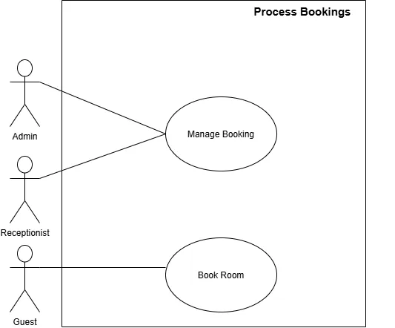
Figure 3.4 System Use Case of Bookings
Written Use Case:
Use Case Name: Book Room
Purpose: Allows the guest to reserve a room for chosen dates and receive a booking reference number.
Actor: Guest
Input Parameters:
- Check-in Date
- Check-out Date
- Number of Guests
- Room Selection
- Guest Details (Name, Email Address, Contact Number)
Output Parameters:
- Booking Reference Number
- Booking Summary
- Validation or Error Message
Pre-Condition:
- Rooms are available for the chosen dates.
- The guest has entered valid guest details.
Post-Condition:
- A booking is saved with a Pending status.
- The guest sees a booking reference number.
- The new booking appears in the list of bookings for the staff.
Successful Scenario:
- The guest opens the Rooms page.
- The guest picks the check-in date, check-out date, and number of guests.
- The system displays the rooms that are available for those dates.
- The guest selects a room.
- The guest enters their details and submits the booking.
- The system validates the details and checks again that the room is still available.
- The system saves the booking with a Pending status.
- The system displays the booking reference number and a summary of the booking.
Exception Scenario:
- If the dates entered are invalid:
○ The system asks the guest to enter valid check-in and check-out dates.
- If no rooms are available for the chosen dates:
○ The system displays a message and asks the guest to try other dates.
- If the room is taken before the guest finishes:
○ The system rejects the booking and asks the guest to pick again.
- If required guest details are missing or invalid:
○ The system asks the guest to complete or correct the required information.
- If the guest submits the same booking more than once:
○ The system blocks the duplicate booking.
Additional Remarks:
- A new booking stays Pending until the staff handle it (see Manage Booking).
- Only rooms marked Available should be shown to guests.
- Payments for the booking are viewed and verified by the staff (see Process Payments).
Written Use Case:
Use Case Name: Manage Booking
Purpose: Allows the admin and the receptionist to view, search, update, and cancel bookings.
Actors: Admin, Receptionist
Input Parameters:
- Search Keyword or Filter (Booking Number, Guest Name, Date, Status)
- Booking Changes (Dates, Room, Status)
Output Parameters:
- List of Bookings
- Booking Details
- Updated Booking
- Confirmation or Error Message
Pre-Condition:
- The admin or receptionist is signed in.
- At least one booking exists in the system.
Post-Condition:
- The booking changes are saved.
- The action is recorded in the audit logs.
Successful Scenario:
- The admin or receptionist opens the Bookings page.
- The system displays the list of bookings with their statuses.
- The admin or receptionist searches or filters to find a booking.
- The admin or receptionist opens the booking and reviews its details.
- The admin or receptionist updates the booking, such as confirming it, changing its dates or room, or cancelling it.
- The system validates the changes and checks the room availability for any new dates or room.
- The system saves the changes and displays a confirmation message.
Exception Scenario:
- If no booking matches the search or filter:
○ The system displays a message indicating that no bookings were found.
- If the new dates or room are not available:
○ The system rejects the change and informs the admin or receptionist.
- If the booking can no longer be changed, such as an already cancelled booking:
○ The system blocks the action.
- If the list of bookings cannot be loaded:
○ The system displays an appropriate error message.
Additional Remarks:
- The admin and the receptionist have the same access in this use case.
- Bookings made by guests through Book Room start as Pending and appear in this list.
- The payments of a booking can be viewed in Process Payments (see View Payment).

3.5 System Use Case of Payments
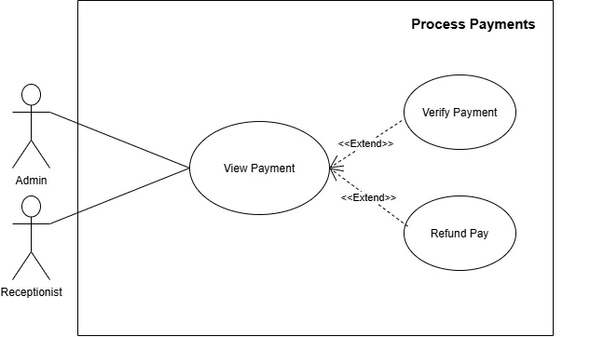
Figure 3.5 System Use Case of Payments
Written Use Case:
Use Case Name: View Payment
Purpose: Allows the admin and the receptionist to view the payment records of bookings.
Actors: Admin, Receptionist
Input Parameters:
- Search Keyword or Filter (Booking Number, Guest Name, Payment Status, Date)
Output Parameters:
- List of Payments
- Payment Details (Booking Number, Amount, Method, Status, Date)
Pre-Condition:
- The admin or receptionist is signed in.
- Payment records exist in the system.
Post-Condition:
- The payments are displayed.
- No data is changed, unless Verify Payment or Refund Pay is performed.
Successful Scenario:
- The admin or receptionist opens the Payments page.
- The system loads the payment records.
- The system displays the list of payments with their booking number, amount, and status.
- The admin or receptionist searches, filters, or opens a payment.
- The system displays the details of the selected payment.
Exception Scenario:
- If there are no payment records yet:
○ The system displays a message indicating that no payments are available.
- If the list of payments cannot be loaded:
○ The system displays an appropriate error message.
Additional Remarks:
- Verify Payment and Refund Pay extend this use case. They are optional and do not happen every time a payment is viewed.
- Verify Payment is only offered for payments that are not yet verified. Refund Pay is only offered for payments that are already verified.
Written Use Case:
Use Case Name: Verify Payment
Purpose: Allows the admin or the receptionist to confirm that a payment for a booking was received and is correct.
Actors: Admin, Receptionist
Input Parameters:
- Selected Payment
- Verification Remarks, if any
Output Parameters:
- Updated Payment Status (Verified)
- Confirmation Message
Pre-Condition:
- The admin or receptionist is signed in.
- The payment record exists and is not yet verified.
Post-Condition:
- The payment is marked as Verified.
- The action is recorded in the audit logs.
Successful Scenario:
- The admin or receptionist opens a payment from the list in View Payment.
- The system displays the details of the payment.
- The admin or receptionist checks the payment details against the booking.
- The admin or receptionist selects Verify Payment.
- The system updates the payment status to Verified and saves it.
- The system displays a confirmation message.
Exception Scenario:
- If the payment is already verified:
○ The system informs the admin or receptionist and makes no change.
- If the payment details do not match the booking:
○ The admin or receptionist does not verify the payment, and its status stays the same.
- If the verification cannot be saved:
○ The system displays an appropriate error message and keeps the old status.
Additional Remarks:
- This use case extends View Payment.
- A verified payment can later be refunded (see Refund Pay).
Written Use Case:
Use Case Name: Refund Pay
Purpose: Allows the admin or the receptionist to refund a payment that was made for a booking, such as for a cancelled booking.
Actors: Admin, Receptionist
Input Parameters:
- Selected Payment
- Refund Amount
- Refund Reason
Output Parameters:
- Refund Record
- Updated Payment Status (Refunded)
- Confirmation Message
Pre-Condition:
- The admin or receptionist is signed in.
- The payment is verified and has not been refunded yet.
Post-Condition:
- The refund is saved with its amount and reason.
- The payment is marked as Refunded.
- The action is recorded in the audit logs.
Successful Scenario:
- The admin or receptionist opens a payment from the list in View Payment.
- The system displays the details of the payment.
- The admin or receptionist selects Refund Pay.
- The admin or receptionist enters the refund amount and the reason.
- The system checks that the refund amount does not go over the amount paid.
- The admin or receptionist confirms the refund.
- The system saves the refund and updates the payment status to Refunded.
- The system displays a confirmation message.
Exception Scenario:
- If the refund amount is missing, invalid, or more than the amount paid:
○ The system rejects the refund and asks for a valid amount.
- If the payment is not verified or is already refunded:
○ The system blocks the refund.
- If the refund cannot be saved:
○ The system displays an appropriate error message and no refund is recorded.
Additional Remarks:
- This use case extends View Payment.
- The original payment record is kept after a refund.

3.6 System Use Case of Offers
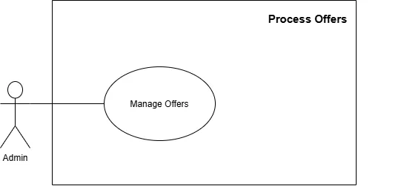
Figure 3.6 System Use Case of Offers
Written Use Case:
Use Case Name: Manage Offers
Purpose: Allows the admin to create, view, edit, activate or deactivate, and delete special offers.
Actor: Admin
Input Parameters:
- Offer Details (Title, Description, Discount, Room Type, Start Date, End Date)
- Offer Status (Active or Inactive)
- Selected Action (Add, Edit, Activate/Deactivate, or Delete)
Output Parameters:
- List of Offers
- Saved Offer
- Confirmation or Error Message
Pre-Condition:
- The admin is signed in.
Post-Condition:
- The offer changes are saved.
- Active offers are shown to the guests.
- The action is recorded in the audit logs.
Successful Scenario:
- The admin opens the Offers page.
- The system displays the list of offers with their statuses.
- The admin chooses to add an offer, edit an offer, activate or deactivate an offer, or delete an offer.
- The admin enters or changes the offer details and saves.
- The system validates the details.
- The system saves the offer and updates the list of offers.
- The system displays a confirmation message.
Exception Scenario:
- If required details are missing or invalid, such as an end date earlier than the start date or an invalid discount:
○ The system asks the admin to complete or correct the required information.
- If the list of offers cannot be loaded:
○ The system displays an appropriate error message.
Additional Remarks:
- Only the admin can manage offers.
- Only active offers within their dates should be shown to guests.
- Deactivating an offer hides it from guests without deleting it.

3.7 System Use Case of Reviews
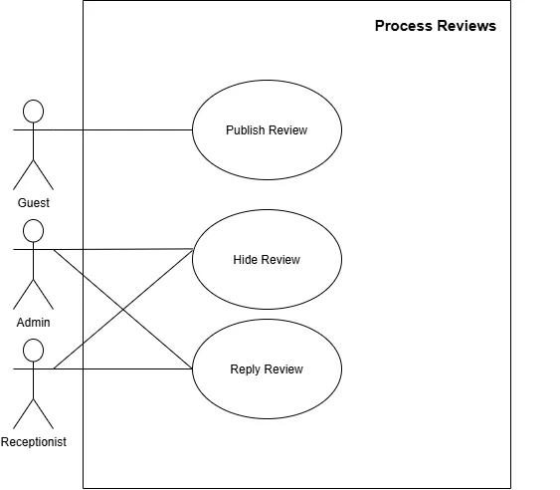
Figure 3.7 System Use Case of Reviews
Written Use Case:
Use Case Name: Publish Review
Purpose: Allows the guest to write and publish a review about a completed stay.
Actor: Guest
Input Parameters:
- Star Rating
- Comment
Output Parameters:
- Published Review
- Confirmation Message
Pre-Condition:
- The guest is signed in.
- The stay is already completed (checked out).
- The stay belongs to the guest.
Post-Condition:
- The review is saved and shown in the public reviews.
Successful Scenario:
- The guest opens a completed stay in their account.
- The guest gives a star rating and writes a comment.
- The guest submits the review.
- The system checks that the booking belongs to the guest and that the stay is completed.
- The system saves and publishes the review.
- The system displays a confirmation message.
Exception Scenario:
- If the stay is not yet completed:
○ The system does not allow the stay to be reviewed.
- If the guest tries to review someone else’s booking:
○ The system blocks the action.
- If the star rating is missing or the comment is invalid:
○ The system asks the guest to complete or correct the review.
- If the booking already has a review:
○ The system does not allow a second review for the same booking.
Additional Remarks:
- Only one review is allowed per booking.
- A published review can be hidden or replied to by the staff (see Hide Review and Reply Review).
Written Use Case:
Use Case Name: Hide Review
Purpose: Allows the admin or the receptionist to hide a published review that should no longer be shown to the public.
Actors: Admin, Receptionist
Input Parameters:
- Selected Review
- Reason for Hiding, if any
Output Parameters:
- Updated Review Status (Hidden)
- Confirmation Message
Pre-Condition:
- The admin or receptionist is signed in.
- The review is published.
Post-Condition:
- The review is hidden from the public reviews.
- The review is still kept in the system.
- The action is recorded in the audit logs.
Successful Scenario:
- The admin or receptionist opens the Reviews page.
- The system displays the reviews with their statuses.
- The admin or receptionist selects a review and chooses Hide.
- The system asks the admin or receptionist to confirm.
- The admin or receptionist confirms.
- The system changes the review status to Hidden and removes it from the public reviews.
- The system displays a confirmation message.
Exception Scenario:
- If the review is already hidden:
○ The system informs the admin or receptionist and makes no change.
- If the review cannot be hidden:
○ The system displays an appropriate error message and the review stays visible.
Additional Remarks:
- Hiding a review does not delete it.
- Both the admin and the receptionist can hide reviews.
Written Use Case:
Use Case Name: Reply Review
Purpose: Allows the admin or the receptionist to reply to a guest’s review on behalf of the hotel.
Actors: Admin, Receptionist
Input Parameters:
- Selected Review
- Reply Message
Output Parameters:
- Saved Reply
- Confirmation Message
Pre-Condition:
- The admin or receptionist is signed in.
- The review exists.
Post-Condition:
- The reply is saved and shown together with the review.
Successful Scenario:
- The admin or receptionist opens the Reviews page.
- The system displays the reviews.
- The admin or receptionist selects a review and chooses Reply.
- The admin or receptionist writes the reply and submits it.
- The system checks that the reply is not empty.
- The system saves the reply and displays it under the review.
Exception Scenario:
- If the reply is empty:
○ The system asks the admin or receptionist to write a reply.
- If the reply cannot be saved:
○ The system displays an appropriate error message.
Additional Remarks:
- The reply is shown as the hotel’s response to the guest’s review.
- A reply does not change the guest’s original review.

3.8 System Use Case of Chatbot
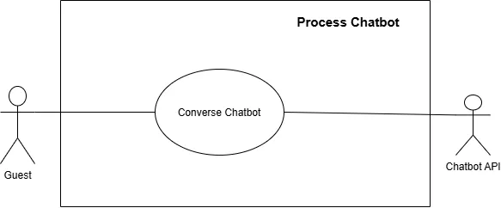
Figure 3.8 System Use Case of Chatbot
Written Use Case:
Use Case Name: Converse Chatbot
Purpose: Allows the guest to ask questions and receive automatic answers from the chatbot.
Actors: Guest, Chatbot API
Input Parameters:
- Chat Message
Output Parameters:
- Reply Message
Pre-Condition:
- The chat feature is turned on.
- The Chatbot API is connected to the system.
Post-Condition:
- The reply is displayed in the guest’s chat.
Successful Scenario:
- The guest opens the chat box.
- The guest types and sends a message.
- The system checks that the message is valid.
- The system sends the message to the Chatbot API.
- The Chatbot API creates a reply and sends it back to the system.
- The system displays the reply in the guest’s chat.
Exception Scenario:
- If the message is empty:
○ The system does not send the message.
- If the Chatbot API is not available:
○ The system displays a backup message and suggests contacting the hotel staff.
- If the guest sends too many messages:
○ The system limits the guest’s messages for a while.
Additional Remarks:
- The Chatbot API is an external service that generates the replies.
- The connection to the Chatbot API is managed by the admin (see Manage API).

3.9 System Use Case of Integration
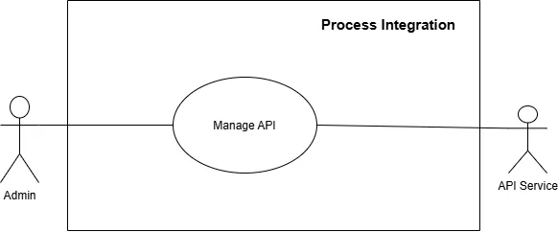
Figure 3.9 System Use Case of Integration
Written Use Case:
Use Case Name: Manage API
Purpose: Allows the admin to add, view, edit, enable or disable, and remove the connections to the external API services used by the system.
Actors: Admin, API Service
Input Parameters:
- API Service Name
- API Key or Credentials
- Endpoint URL
- Status (Enabled or Disabled)
- Selected Action (Add, Edit, Enable/Disable, or Remove)
Output Parameters:
- List of API Connections
- Connection Test Result
- Saved API Settings
- Confirmation or Error Message
Pre-Condition:
- The admin is signed in.
Post-Condition:
- The API settings are saved.
- Enabled services are used by the system, and disabled services are switched off.
- The action is recorded in the audit logs.
Successful Scenario:
- The admin opens the Integration page.
- The system displays the list of API connections with their statuses.
- The admin chooses to add, edit, enable or disable, or remove an API connection.
- The admin enters or changes the API details and saves.
- The system validates the details.
- The system tests the connection with the API Service.
- The API Service responds to the test.
- The system saves the settings and displays a confirmation message.
Exception Scenario:
- If required details are missing or invalid:
○ The system asks the admin to complete or correct the required information.
- If the API Service cannot be reached or does not accept the credentials:
○ The system displays an error message and does not enable the connection.
- If the admin disables a service:
○ The features that depend on it are turned off or show a backup message.
Additional Remarks:
- Only the admin can manage API connections.
- API keys and credentials are stored securely and are hidden on the screen.
- The API Service is an external system, such as the chatbot, OAuth, or email (SMTP) service.

3.10 System Use Case of Data and Trails
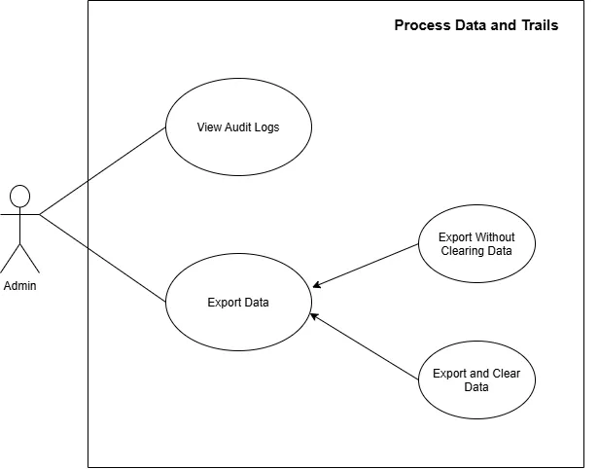
Figure 3.10 System Use Case of Data and Trails
Written Use Case:
Use Case Name: View Audit Logs
Purpose: Allows the admin to view the record of actions done in the system, showing who did what and when.
Actor: Admin
Input Parameters:
- Search Keyword or Filter (User, Action, Date Range)
Output Parameters:
- List of Audit Log Entries (User, Role, Action, Date and Time)
Pre-Condition:
- The admin is signed in.
- System actions have been recorded in the audit logs.
Post-Condition:
- The matching audit log entries are displayed.
- No data is changed.
Successful Scenario:
- The admin opens the Audit Logs page.
- The system loads the audit logs, with the newest entries first.
- The system displays the list of entries.
- The admin enters filters to narrow the results.
- The system displays the matching entries.
Exception Scenario:
- If no audit log entry matches the filters:
○ The system displays a message indicating that no matching activity was found.
- If the audit logs cannot be loaded:
○ The system displays an appropriate error message.
Additional Remarks:
- Only the admin should have access to the audit logs.
- Audit log entries are view-only and cannot be edited.
Written Use Case:
Use Case Name: Export Data
Purpose: Allows the admin to export system records, such as bookings and payments, into a downloadable file for reports and record keeping.
Actor: Admin
Input Parameters:
- Type of Data to Export
- Date Range
- Export Option (Export Without Clearing Data or Export and Clear Data)
Output Parameters:
- Downloadable Export File
- Confirmation or Error Message
Pre-Condition:
- The admin is signed in.
- There are records to export.
Post-Condition:
- The export file is ready for download.
- The export is recorded in the audit logs.
Successful Scenario:
- The admin opens the Data page.
- The admin selects the type of data and the date range.
- The admin chooses an export option: Export Without Clearing Data or Export and Clear Data.
- The admin confirms the export.
- The system collects the matching records.
- The system creates the export file.
- The system makes the file available for download and records the export in the audit logs.
Exception Scenario:
- If there are no records in the selected date range:
○ The system displays a message indicating that there is nothing to export.
- If the export file cannot be created:
○ The system displays an appropriate error message and no data is cleared.
- If a user other than the admin tries to export data:
○ The system blocks the action.
Additional Remarks:
- Export Without Clearing Data and Export and Clear Data are the two ways this use case can be done.
- Only the admin can export data.
Written Use Case:
Use Case Name: Export Without Clearing Data
Purpose: Allows the admin to export a copy of the records while keeping them in the system.
Actor: Admin
Input Parameters:
- Type of Data to Export
- Date Range
Output Parameters:
- Downloadable Export File
Pre-Condition:
- The admin is signed in.
- There are records to export.
Post-Condition:
- The export file is ready for download.
- The exported records remain in the system.
- The export is recorded in the audit logs.
Successful Scenario:
- The admin opens the Data page and selects Export Without Clearing Data.
- The admin selects the type of data and the date range.
- The admin confirms the export.
- The system collects the matching records and creates the export file.
- The system makes the file available for download.
- The system keeps the records unchanged and records the export in the audit logs.
Exception Scenario:
- If there are no records in the selected date range:
○ The system displays a message indicating that there is nothing to export.
- If the export file cannot be created:
○ The system displays an appropriate error message.
Additional Remarks:
- This is a specific way of doing Export Data.
- This is the safe option when the records are still needed, such as for a backup or a report.
Written Use Case:
Use Case Name: Export and Clear Data
Purpose: Allows the admin to export the records to a file and then remove them from the system.
Actor: Admin
Input Parameters:
- Type of Data to Export
- Date Range
Output Parameters:
- Downloadable Export File
- Confirmation or Error Message
Pre-Condition:
- The admin is signed in.
- There are records to export.
Post-Condition:
- The export file is ready for download.
- The exported records are cleared from the system.
- The export and clearing are recorded in the audit logs.
Successful Scenario:
- The admin opens the Data page and selects Export and Clear Data.
- The admin selects the type of data and the date range.
- The system warns the admin that the exported records will be removed from the system.
- The admin confirms.
- The system collects the matching records and creates the export file.
- The system makes the file available for download.
- The system clears the exported records.
- The system records the export and clearing in the audit logs.
Exception Scenario:
- If the admin cancels at the warning:
○ The system does not export or clear anything.
- If the export file cannot be created:
○ The system displays an appropriate error message and no data is cleared.
- If the records cannot be cleared:
○ The system displays an appropriate error message and keeps the records that were not cleared.
Additional Remarks:
- This is a specific way of doing Export Data.
- Records are only cleared after the export file is created successfully.
- Clearing cannot be undone, so the export file should be kept safe.

